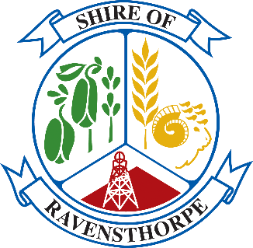

Community Development Grants
2023/24 Guidelines & Application Form

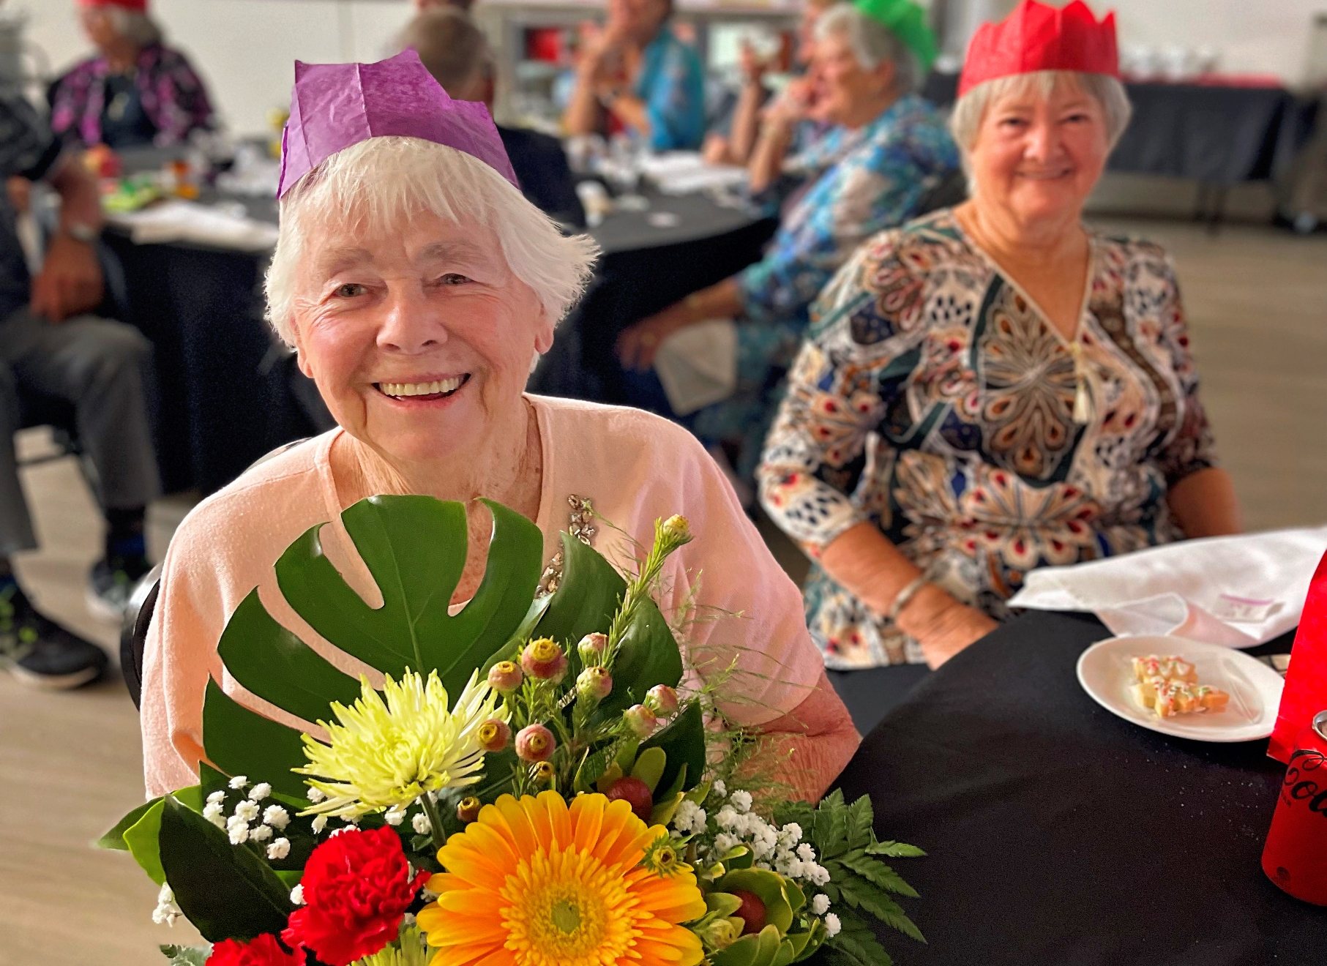

Community development fund

GUIDELINES & aPPLICATION FORMs

Introduction
Each year Ravensthorpe Council considers funding local community and sporting groups via its Community Development Fund and is guided by policy G.20 Community Development Fund (CDF).
At the February 2023 Ordinary Council Meeting, Council endorsed a revised CDF policy for implementation in the 2023/24 financial year period.
The revised CDF offers 4 categories for funding with each category having a specific focus, maximum funding level, and application and acquittal requirements.
Each year the level of community funds available will be up to a maximum of 1.5% of the prior year’s rates revenue. Applicants should review the policy detail prior to applying for funding.

Community Development Fund categories
Council will consider allocation of funds for each year’s CDF program across the following 4 categories;
1. General Community Grants (groups and projects):
Local community groups and not for profit organisations may apply for funding for projects and activities that benefit communities within the Shire of Ravensthorpe up to maximum of $3,500 ex GST.

2. Community Events:
Local community groups may apply for up to a maximum of $5,000 ex GST for events that are targeted primarily at a local audience. Community events may create increased vibrancy, activate public places, and/or target specific groups within the local community.

3. Major Events:
Event organisers may apply for up to $10,000 ex GST for events that are delivered within the Shire and have significant economic benefit to the Ravensthorpe community during non-peak periods.
Eligible events include, but not limited to sporting, recreational, music, cultural, food and wine, special interest, and business meetings that have the potential to attract significant numbers from outside the region and that ultimately generate additional expenditure into the Ravensthorpe economy.
The Shire will only fund Major Events staged outside of the defined Peak period to encourage economic visitor spend during shoulder and low seasons.

4. Shire President Donations:
Local community groups or individuals (where an individual can demonstrate sufficient justification for the provision of financial assistance) may apply for up to $750 ex GST. The Donations category is provided to cover any applications that may not qualify for the other stated CDF categories, and may be applied for at any time of the year subject to funds still being available. See separate Shire President Donations guidelines and application form.
Application and Assessment
All applications shall be made on the forms available from the Council.
Applicants must address the selection criteria provided within the application guidelines.
Only one application per group will be funded across the four categories each financial year (an auspicing group will not limit their own group’s ability to apply for funding).
Funds will be allocated at the discretion of Council and based on highest merit and greatest benefit to the Shire of Ravensthorpe residents and community.
The grant amounts detailed for each category are maximums and should not be viewed as a guarantee of that level of funding. Council may decide to award part or none of the amounts requested.
Additional Shire President Donations may be considered in exceptional circumstances.
Unsuccessful applicants will be advised and will need to reapply in the next year if the funding assistance is still required at that time.

Timelines
The CDF program will be open to receive applications in March each year.
Council will then consider applications for inclusion in the following year’s annual budget. There will be one round of funding applications each year with the following timelines for the 2023/24 period;

Grants applications | Opens 1 March 2023 and Closes 31 March 2023
Council assessment and formal decision | April – May 2023
Applicant notification | 31 May 2023
Funds available for drawdown | From July 2023

Eligibility
Funding from CDF categories is available to local community groups as defined in the Policy.
A community group means any group which has as its members, members of the Shire of Ravensthorpe community and which operates on a “not for profit” basis. A community group may have a formal governance structure or may be a less structured group.
The Shire will not fund retrospective or deficit funding, government or quasi government agencies excluding local schools.

Administration of Funds
All approved grant funds will be released in the new financial year and must be claimed and acquitted in the financial year it is provided.
Funds will only be paid to incorporated groups which have a current ABN and on submission of a tax invoice.
Groups which are not incorporated are able to apply for funding but must nominate in their application the name and ABN of an auspicing group which will receive and acquit the funds on their behalf if the application is successful. An auspicing group will not limit their own group’s ability to apply for funding.
Only Shire President Donations may be paid to non-incorporated groups or individuals.

Assessment Criteria

Applicants are required to address the assessment criteria for each category of grant funding as contained within the respective application form.

Key criteria to address is as follows;

1. General Community Grants (groups and projects):
Demonstrate benefits to be delivered to the local community.

2. Community Events:
Demonstrate how proposed event will increase vibrancy, activate public places, and/or benefit specific groups within the local community.

3. Major Events:
Demonstrate how proposed event will benefit the Ravensthorpe community during non-peak periods by attracting significant numbers of visitors from outside the region and that generates additional expenditure into the Ravensthorpe economy.

4. Shire President Donations:
See separate Shire President Donations guidelines and application form.

Conditions of Funding

Successful applicants will be required to sign a funding agreement with the Shire outlining conditions of funding that may include, but not limited to;
- Recognition of the Shire as an event sponsor or project partner in all publicity material, eg social media, print and digital advertising, posters, printed material.
- Invitation for Shire representatives to attend any associated events.
- Opportunity to display Shire signage and other marketing material at event, program or project.

Other Approvals

Applicants who receive CDF funding must still seek all relevant Shire approvals (eg event or
building permits) from the Shire of Ravensthorpe.

CDF approval does not confer any additional approvals apart from granting of the funds.
CDF APPLICATION FORM
Please ensure that you have read the Shire of Ravensthorpe Community Development Fund policy and guidelines before completing the below application form. We also recommend you contact the Shire of Ravensthorpe officers to discuss your application before applying.

Funding category and amount being applied for (note groups can only apply for one category each year - please tick one category box only)
Funding category being applied for | Funding amount requested $
☐ General Community Grant | Click or tap here to enter text.
☐ Community Events | Click or tap here to enter text.
☐ Major Events | Click or tap here to enter text.
Shire President Donation | Please use separate SP Donation form and guidelines

Contact Information
Contact person | Click or tap here to enter text.
Name of organisation and position | Click or tap here to enter text.
Address | Click or tap here to enter text.
Phone number | Click or tap here to enter text.
Email | Click or tap here to enter text.

Checklist (please tick where relevant)
I have read the Shire Community Development Fund policy and guidelines | ☐
My organisation is eligible to apply for this funding | ☐
My organisation has an Australian Business Number? Please detail below.  Click or tap here to enter text. | ☐
My organisation is registered for GST | ☐
Are you an employee or contractor working for the Shire of Ravensthorpe or a close relative? *If yes we will contact you to determine any potential conflict of interest | ☐
Are you auspicing this application on behalf of a local community group? Please detail name of group Click or tap here to enter text. | ☐

Declaration
I, the undersigned, confirm that as Click or tap here to enter text. (state position within applicant organisation) of the Click or tap here to enter text. (state applicant organisation name) have carefully reviewed and considered the responses and the information provided is true and correct.

Signed: ______________________________ Date: _____________________________

Project or Event Information
Project / Event name | Click or tap here to enter text.
Project / Event dates | Click or tap here to enter text.
If this is a recurring project/event, how often is the project/event held? | Click or tap here to enter text.
Location of project/event? | Click or tap here to enter text.
Briefly describe the project / event (max 200 words)
Click or tap here to enter text.

How will your project / event meet the below relevant category criteria? (max 200 words)
1. General Community Grants (groups and projects): Demonstrate benefits to be delivered to the local community.
2. Community Events: Demonstrate how proposed event will increase vibrancy, activate public places, and/or benefit specific groups within the local community.
3. Major Events: Demonstrate how proposed event will benefit the Ravensthorpe community during non-peak periods by attracting significant numbers of visitors from outside the region and that generates additional expenditure into the Ravensthorpe economy.
Click or tap here to enter text.

What experience has your group had with similar projects / events?
Click or tap here to enter text.

Budget
For General Community Grants please provide at least 1 quote for items to be purchased or services supplied.
For Community Events please provide a separate event budget. Sample budget template attached.
For Major Events please provide a detailed budget including quotes for various items and services to be contracted. Sample budget template attached.

Evaluation
How will you measure the success of your project or event? For example questionnaires, surveys, ticket sales, member or participant feedback…
Tool | What are you measuring?
Eg event participant survey | Economic benefit, visitor origin demonstrating out of region visitation,
Click or tap here to enter text. | Click or tap here to enter text.
Click or tap here to enter text. | Click or tap here to enter text.
Click or tap here to enter text. | Click or tap here to enter text.
Click or tap here to enter text. | Click or tap here to enter text.

Submitting Completed Applications
Completed applications should be mailed or submitted in person to:
CEO
Community Development Fund
65 Morgans St Ravensthorpe
Ravensthorpe WA 6346

Electronic submissions should be emailed to shire@ravensthorpe.wa.gov.au with subject line: 2023/24 CDF application.

CDF Application Deadline 31 March 2023

